**System Analysis**

**Software Development Model**

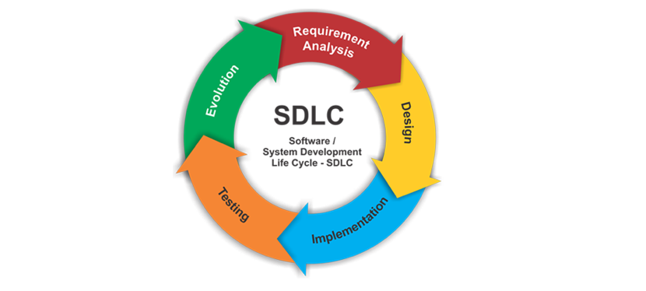

The web application “**Tourism Management System**” is developed using “**spiral Model Of Software Development Process Model**”. During the development process first the objective & requirement of a particular features is determined. After the completion of first phase Based on the determined requirements a prototype is made and yest again. This process continued till determined requirement meets the user’s requirement. Now next phase is Development & Testing phase in wich details for the module is made and coding is done based on design. The code is then tested to complete the implementation of the feature. The whole process and phase is repeated to implement all other features.